**APPENDIX C: TEST CASES WITH RESULTS**

|  |  |  |  |  |
| --- | --- | --- | --- | --- |
| Test Case ID | Steps (Description) | Expected results | Actual result | Success  (yes/no) |
| 1 | Add New Course | | | |
| 1.1 | Keep the fields empty and click ‘Register’ button | Show message  “Please fill all the fields” | “Please fill all the fields” | YES |
| 1.2 | Fill some fields and click ‘Reset’ button | All the fields should empty | All the filled details are cleared | YES |
| 1.3 | Fill all the fields correctly and press ‘Register’ | Show message  “Course successfully created” | Course successfully created | YES |
| 1.4 | Select “Lab2”, (Lab number) and ‘Sunday’(Course ate)for the course after entering all the details and click register | chosen lab number and day allocated correctly and inserted into the database table | Course is created in the database with correct chosen lab number and day | YES |
| 2 | Register Student | | | |
| 2.1 | Keep the field names empty and press register | message displayed  “Please fill all the fields” | Popup -“Please fill all the fields” | YES |
| 2.2 | Fill some fields randomly and click ‘Reset’ | All fields should be cleared and reset | The fields are cleared and reset successfully | YES |
| 2.3 | Fill all fields and choose course “Business IT” and enter 500000 in ‘paid’ field. And press ‘Register’ | Assign the relevant course to student and insert into database | chosen lab number and day is correctly inserted in the database table | YES |
|  |  |  |  |  |

|  |  |  |  |  |
| --- | --- | --- | --- | --- |
| Test Case ID | Steps (Description) | Expected results | Actual result | Success  (yes/no) |
| 3 | Assign lab to course | | | |
| 3.1 | Click ‘Assign lab’ in main window. | Currently allocated courses to the labs should be displayed in each lab number | It is shown correctly (Lab1: Software Engineering)  (Lab2: Aircraft engineering) | YES |
| 3.2 | Choose the course name ‘Business IT’ under **Lab1** and choose ‘Tuesday’ and press ‘Reallocate Lab 1’ | Business IT should be allocated to Lab1 and access day should be only Tuesday, All the consumers’ of this course RFID numbers should allocated to Lab1. Send SMS to all the students and the lecturer of this course, informing the changes. | Business IT Lab number is updated to ‘Lab1’. Day is updated to ‘Tuesday’. All RFID card head part updated to Lab1. And SMS sent to all the related personnel | YES |
| The RFID card which had Access Granted for Lab 1 should deny access. And Access should be granted for Lab 2 | A RFID card which had access to Lab 1 is now not accessible in there, and accessible in Lab 2 | YES |
| 4 | Class room simulator | | | |
| 4.1 | Swipe A unregistered RFID card (card no.229109) to Lab1 reader | Show message in simulator in LCD panel - Lab1 in  “Access Denied card no. 229109” & display “Not this class” in Real LCD panel | Message displayed as ‘Not this class’ in LCD panel  and  “Access Denied card no. 229109”  In simulator | YES |
| 4.2 | Click “Close door” in simulator | This action should Display “Door closed” in simulator | The test “Door opened” changed to “Door closed” | YES |
| 4.2.1 | Click “Close door” in simulator | Close the door of the door model | Not developed the automatically door closing mechanical part | NO |
| 5 | View course , View Students, View Lecturers | | | |
|  | Click “View course”, “View Students”, “View Lecturers” and check | All the courses, students and Lecturers available in database should be displayed in here as a table format | All courses, students and lecturers are displayed correctly | YES |

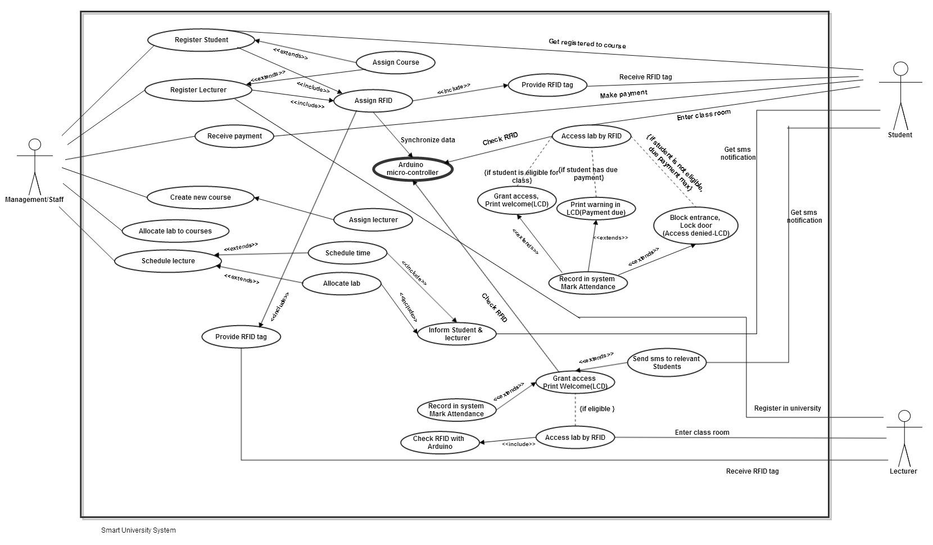**APPENDIX D: USE CASE DIAGRAM**

**APPENDIX E: CLASS DIAGRAM**